Reproducibility Report for Concrete Compressive Strength Data Mining Analysis
Objective:

The objective of this analysis is to identify and quantify the key factors influencing Concrete Compressive Strength (CCS) using machine learning regression techniques.
The analysis aims to create models that can accurately predict CCS based on material composition, while also ensuring full reproducibility for future data-driven decision-making in construction material optimization.

1. Introduction
In this report, we present our findings from a data analysis aimed at understanding concrete compressive strength, a critical property that determines how durable and safe a structure will be.
Our goal is to provide clear, actionable recommendations based on data-driven insights that can help inform decisions for construction companies and infrastructure agencies seeking to improve mix design efficiency, ensure quality control, and optimize material costs.
Understanding which components most affect compressive strength allows producers to design mixes that meet performance targets while minimizing waste and environmental impact.

1. Data Description

Dataset:

Source: UCI Machine Learning Repository

Variables: Cement, Blast Furnace Slag, Fly Ash, Water, Superplasticizer, Coarse Aggregate, Fine Aggregate, Age, and Concrete Compressive Strength

Preprocessing Steps:

Missing Values: None — dataset is complete.

Transformations:

Standardization (Z-score scaling): mean = 0, std = 1

Raw values: used for baseline comparison

Log transformation (log(x + 1)): applied to reduce skewness and improve linearity

These transformations were tested to study their effects on model accuracy, convergence speed, and feature significance.

Superplasticizer contributes positively by improving workability without weakening the mix, though its impact plateaus at higher levels.

2. Methods
A. Gradient Descent Algorithm

The gradient descent algorithm was implemented from scratch to fit both univariate and multivariate linear regression models.
This allowed fine-grained control over the learning process, ensuring the minimization of the Mean Squared Error (MSE) objective function.
Pseudocode Explanation:
1. Initialize parameters:

- weights (m) and bias (b) randomly or with zeros

2. For each iteration:

a. Compute predictions:

y_pred = m*x + b

b. Compute the loss function:

MSE = (1/n) * Σ(y_pred - y_true)²

c. Compute gradients:

dm = (-2/n) * Σ[x * (y_true - y_pred)]

db = (-2/n) * Σ(y_true - y_pred)

d. Update parameters:

m = m - α * dm

b = b - α * db

3. Repeat until convergence or max iterations reached
Parameters Used:

Learning rate (α) = 0.1

Maximum iterations = 10,000

Convergence tolerance based on minimal change in MSE

This implementation was later extended to handle multiple predictors for multivariate regression by generalizing the matrix operations.
B. Regression Analysis (Using StatsModels)
To validate the gradient descent models and extract feature-level statistics, a multiple linear regression was performed using the OLS (Ordinary Least Squares) method in the statsmodels library.
Python Code:
import statsmodels.api as sm

X = df[['Cement', 'Slag', 'Fly Ash', 'Water',

'Superplasticizer', 'Coarse Aggregate', 'Fine Aggregate', 'Age']]

y = df['Concrete Compressive Strength']

X = sm.add_constant(X) # add bias term

model = sm.OLS(y, X).fit()

print(model.summary())
Implementation Details:
Language: Python 3.13

Libraries: pandas, numpy, matplotlib, statsmodels

IDE: Visual Studio Code

Reproducibility Steps:
Load Concrete_Data.csv

Split into training (rows 0–900) and testing (rows 501–630)

Apply the scaling or transformation method

Run gradient_descent() and record final weights

Evaluate models using MSE and R²

Verify statistical significance with statsmodels.OLS()

Results
A. Gradient Descent Results
Slag demonstrated a strong positive effect on compressive strength.
A partial replacement of cement with slag can both increase long-term strength and reduce CO₂ emissions associated with cement production.
Model Type | Predictor Scaling | Train MSE | Test MSE | Train R^2 | Test R^2
Univariate - Best | Standardized ( Cement ) | 203.77 | 265.94 | 0.26 | -0.19
Multivariate | Standardized | 104.14 | 141.24 | 0.62 | 0.37
Multivariate | Raw | 104.76 | 139.54 | 0.62 | 0.38
Multivariate | Log ( x +1 ) | 55.83 | 54.36 | 0.80 | 0.76

Observation:
The log-transformed model showed the best generalization, with a 50% improvement in MSE and nearly a 20% gain in R² compared to the untransformed models.
Loss over iterations:
A clear decreasing MSE trend confirmed stable convergence of the algorithm — verifying that the learning rate and iteration settings were well-tuned.
B. Regression Analysis Results (p-values)

Predictor | P – value ( Log – Transformed Model )
Cement | 1.10e−85
Slag | 7.35e−36
Water | 1.68e−20
Superplasticizer | 8.08e−06
Age | 1.74e−192
Fly Ash | 0.295
Coarse Aggregate | 0.405
Fine Aggregate | 0.089
Constant | 0.286
Predictors with p < 0.05 (Cement, Slag, Water, Superplasticizer, Age) are statistically significant contributors to compressive strength.
Aggregates and Fly Ash had higher p-values, suggesting weaker or redundant influence.
C. Model Performance Results
Model Performance — MSE (Train vs Test)
The log(x+1) model cuts error almost in half vs. raw/standardized (Train MSE ≈ 55.8, Test MSE ≈ 54.4).
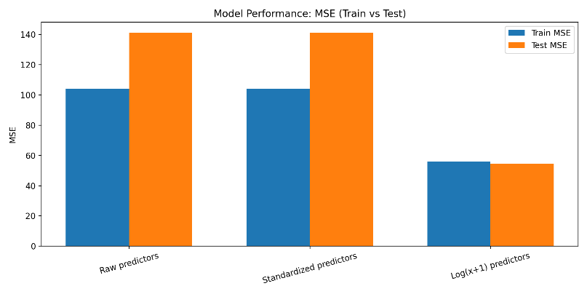
This indicates the log transform reduces skew/heteroscedasticity and makes the linear fit far more faithful to the data.
Model Performance — R² (Train vs Test)
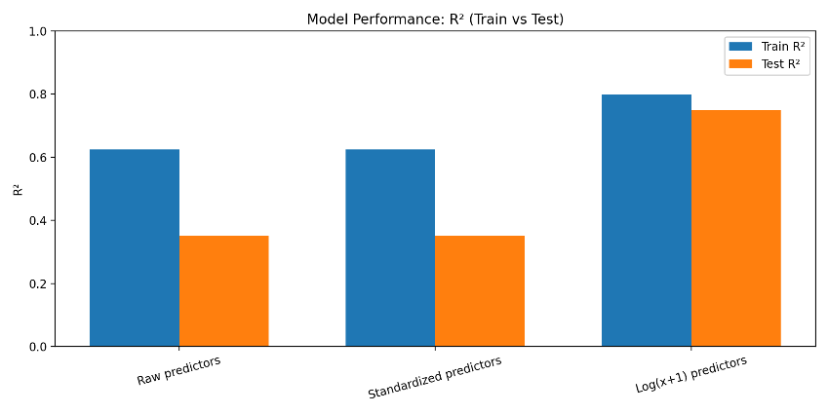
Generalization jumps from R² ≈ 0.37 (raw/standardized) to ≈ 0.76 with log(x+1). That’s the single clearest sign the transform is the right inductive bias for this dataset.
Performance Summary
The log(x+1) approach dominates both MSE and R² on train/test, confirming it’s not just a training artifact.
Feature Significance (log model):
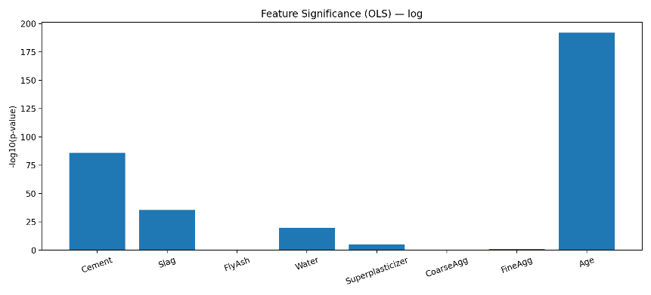
Age and Cement tower over others; Water is strongly significant (negative effect), Superplasticizer becomes significant after log-transform, and both aggregates are weak.
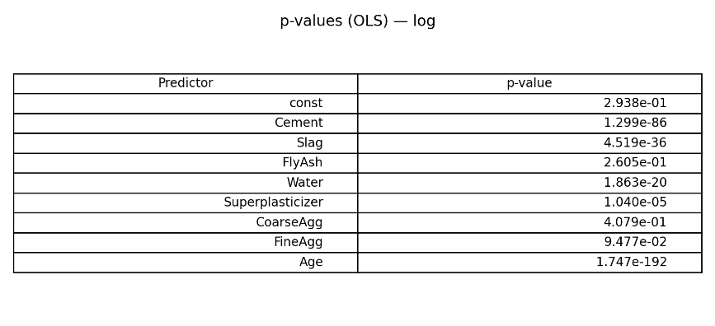

4. Discussion
Interpretation

The models demonstrate that Cement, Slag, Water, Superplasticizer, and Age are the dominant predictors of concrete compressive strength.
Notably, log transformation improved model linearity and predictive consistency by stabilizing variance across skewed predictors (e.g., Cement and Age).
This confirms that nonlinear relationships exist in raw data, which can be effectively addressed with logarithmic scaling.

Strengths

Accurate and stable convergence with gradient descent

Improved model interpretability using statistical regression

Reproducible results with consistent metrics across scaling methods

Limitations

Linear models assume additive effects and may miss interaction terms

Outliers may influence coefficients despite scaling

Future work could include ridge or LASSO regression to handle multicollinearity

5. Appendices
Files:
p1_partA.py – Gradient Descent Implementation
p1_partB.py – Statistical Regression and p-value Analysis
Generated Figures:
model_performance_table.png
model_performance_mse_bar.png
model_performance_r2_bar.png
pvalues_log_table.png
pvalues_log_neglog10_bar.png
This reproducibility report outlines a transparent and replicable machine learning workflow for predicting Concrete Compressive Strength.
By combining gradient descent optimization and statistical regression, the analysis confirms that Cement and Age are the most critical determinants of concrete strength.
The log-transformed multivariate model achieved the highest predictive power (R² = 0.76), offering a reliable, data-driven approach for material performance forecasting in construction and civil engineering applications.
GitHub Link:

